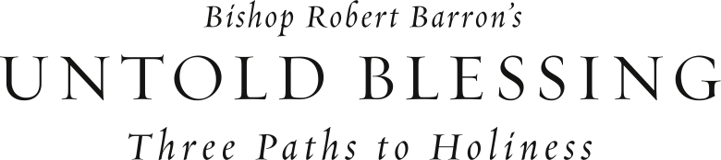

God calls each of us to become a saint, and he’s ready to support us along the way by providing abundant blessings. Join us as we seek these blessings by participating in Bishop Robert Barron’s DVD-based program: *“Untold Blessing: Three Paths to Holiness.”* The first path is “Finding the Center in Christ;” the second is “Knowing You Are a Sinner” and then the third, “Realizing Your Life is Not About You.”

On ­­­­­­___________________________, our parish will begin the *Untold Blessing: Three Paths to Holiness* program. To find out more information, please contact ___________________ or stop by the parish office to sign up.