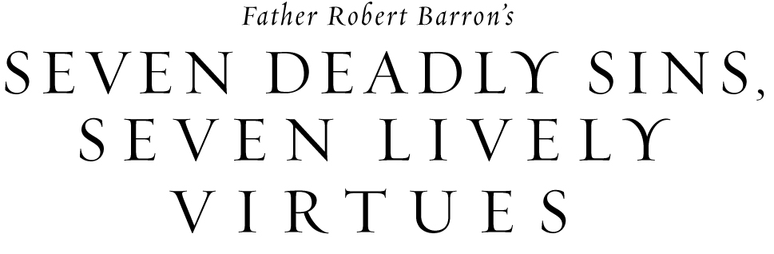

Pride, envy, anger, sloth, greed, gluttony and lust: these “seven deadly sins” are patterns of dysfunction that keep us separated from God and ultimately lead to unhappiness. Join us as we embark on Fr. Robert Barron’s exploration of these seven sinful patterns and also learn how practicing countervailing virtues can break the cycle of sin.

On _____, our parish will begin the Seven Deadly Sins and Seven Lively Virtues program. To find out more information, please contact ___________ or stop by the parish office to sign up.

