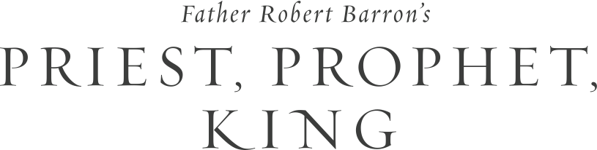

Jesus is the Anointed One – the ultimate priest, prophet and king foreshadowed throughout the Hebrew Scriptures. Join us as we deepen our relationship with Jesus Christ through Fr. Robert Barron’s new DVD-based Study Program: *Priest, Prophet, King.*

Explore the biblical archetypes of priest, prophet and king and see how Jesus is the ultimate fulfillment of each one. Throughout this experience, you will better understand who Jesus really is and also realize your own priestly, prophetic and kingly mission.

On ­­­­­­_____, our parish will begin the *Priest, Prophet, King* study program.

To find out more information, please contact ___________ or stop by the parish office to sign up.

Thank you.