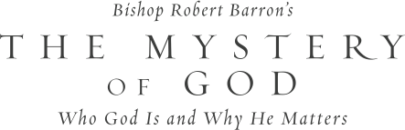

Atheism is on the rise. Skeptical thinkers attack belief in God as irrational or, even worse, dangerous. The so-called New Atheism has attracted millions of young people thanks to bestselling books such as The God Delusion and God Is Not Great. How should Christians respond? How can we turn the tide of secularism and draw people back to God?

In *The Mystery of God: Who God Is and Why He Matters*, Bishop Robert Barron reaches into our rich intellectual tradition to teach us how. Using the insights of St. Augustine, St. Thomas Aquinas, Pope Benedict XVI, he uncovers a clear yet sophisticated understanding of what we mean by “God.”

On ­­­­­­_______________, our parish will begin the *Mystery of God: Who God Is and Why He Matters*, program. To find out more information, please contact __________________ or stop by the parish office to sign up.