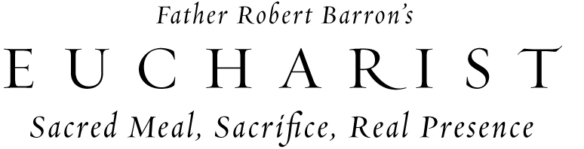

Christ is alive and fully present in the Eucharist. Join us as we delve into the “source and summit” of our Faith with Fr. Robert Barron’s DVD-based program: Eucharist: Sacred Meal, Sacrifice and Real Presence. This spiritual study will give you a deeper understanding of the precious gift of Christ’s body, blood, soul and divinity that you can receive at each and every Mass.

On _____, our parish will begin the Eucharist program.
To find out more information, please contact ___________ or stop by the parish office to sign up.

