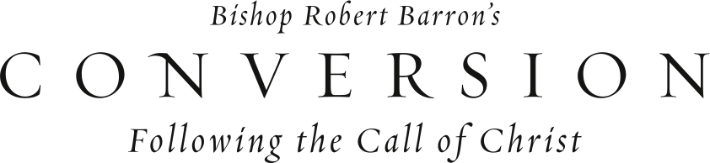

When you hear the word “Conversion,” what comes to mind? Catholicism defines “conversion” as a life-long process of turning one’s attention and energy toward an ever-deepening relationship with Christ. Join us as we begin the DVD-based program, *Conversion: Following the Call of Christ,* presented by Fr. Robert Barron.

Using six stories from the Bible, Bishop Barron demonstrates how ordinary, sinful people like us are met by Jesus and called to a better life through him.

On ­­­­­­__________________________________, our parish will begin the *Conversion: Following the Call of Christ* program. To find out more information, please contact ______________ or stop by the parish office to sign up.