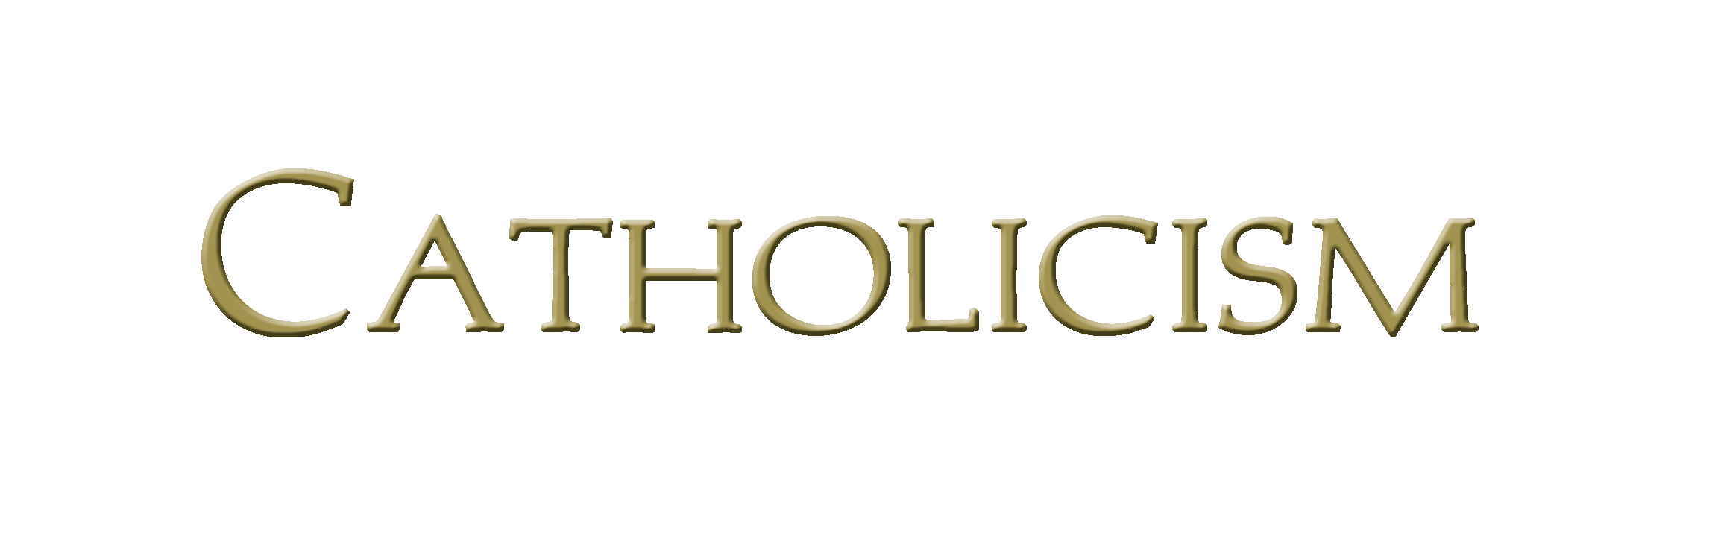Bishop Robert Barron’s Catholicism Series Study Program Registration

To register for the upcoming Catholicism Series program, please complete this form and return it to the Rectory along with the $________ registration fee by ________________,.

Name __________________________________________________________________________________

Address________________________________________________________________________________

City ______________________ Preferred phone number: ___________________________

Email address: ________________________________________________________________________

Have you ever participated in a formation program? _________ Yes ________ No

If yes, approximately how many programs have you completed? ________________

